ORIGINAL
BY THIS POWER OF ATTORNEY given on the day HIGHLAND MOTORS PROPERTIES LIMITED a company incorporated in Nigeria and having its head office at Room 140 Sheraton Lagos Hotel and Tower Ikeja Lagos hereinafter referred to as the Company DOES HEREBY APPOINT EMMA UKORI AND COMPANY LIMITED ( Estate Surveyors and Valuer ) with its Head Office situate at No. 90 Effurun Warri Road Warri Delta State hereinafter referred to as the Attorney as its behalf to do execute all or any of the acts and things hereinafter mentioned, that is to say:-
- To take possession of the Company's landed properties listed in the scheduled to these presents for the purpose of managing same.
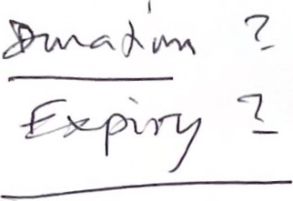
- To let for rent (if vacant), renew leases and tenancies of the properties aforesaid to tenants of its choice at a rent and/or premium that may be determined by it from time to time at a fee of 10% in accordance with the scale of professional charges of the Nigerian Institute of Estate Surveyors and Valuers.
- To manage and superintend the management of the said properties
- To collect rents therefrom whether in arrears or rents therefrom as they shall become due and payable and to give receipts and discharge for same
- If the said money being rents or any part thereof is not paid, to take any legal or other proceedings authorized by law in the Company's name or in its own name for the recovery of same.
- To ward off, prohibit and if necessary, proceed to litigation against trespassers on the said properties or to repair, abate a nuisance, eject tenant(s), remedy breach of covenants and to enforce all remedies open to the Company in respect thereof and/or in exercise of any right of re-entry or other right of entry vested in the Company, without any reference to it.
- To represent the Company and appear in court or before any rent tribunal and on the company's behalf to carry on and prosecute all cases and proceedings which might have been instituted or shall hereafter be instituted in any court of Law of before any rent tribunal against any tenant at the said properties.
- To defend any suit or action or counterclaim proceedings instituted against the Company in respect of the said properties by anyone whosoever.
- To do all such things and exercise all such powers for the successful prosecution of the cases as the Company would have done, and if judgement is obtained, to levy execution and enforce the judgement on its behalf and sign all necessary papers for that purpose.
- To bring to the Company's attention all repairs on its part to be effected on the properties, and thereafter to effect such repairs as are required of the Company.
- To protect the Company's interest in the best manner they think proper with regard to the said properties.
- Generally to do all such other lawful acts and things as it shall think advisable for the purposes aforesaid as fully and effectually in all respect as could have been done by the Company.
- To insure and keep insured the said properties in the Company's name with any insurance company of repute.
THE COMPANY hereby agrees and declares as follows:
  - That it shall ratify and confirm whatever the Attorney shall lawfully do or cause to do be done in pursuance of the power contained in these presents.
  - That it shall sign and execute all papers and documents the Attorney may request it to sign by virtue of this Power of Attorney, provided always that it is in furtherance of the purpose of these presents.
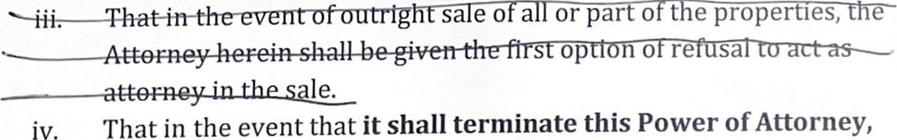
s op no re sa
in
That
this Power of Attorney, for whatever reason, it shall indemnify the Attorney, for whatever reason, it shall indemnify the Attorney for all reasonable expenses and reimbursables incurred in respect of the management of these properties.

SCHEDULE
The entire premises of the HML PROPERTIES LIMITED at Effurun, opposite Urhobo College, Warri, Delta State.
IN WITNESS WHEREOF THE COMPANY hereunto caused its seal to be affixed to the presents the day and year first above written.
The common seal of the within-named Company was hereunto affixed

In the presence of:
GOODIE M. IBRU (SECRETARY)
(DIRECTOR)

